**Exp. No : 5**

**HIVE Installation**

1. Download and Extract apache hive 3.1.2

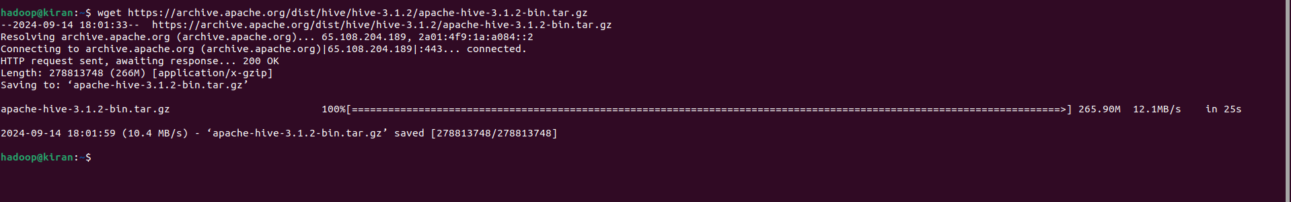

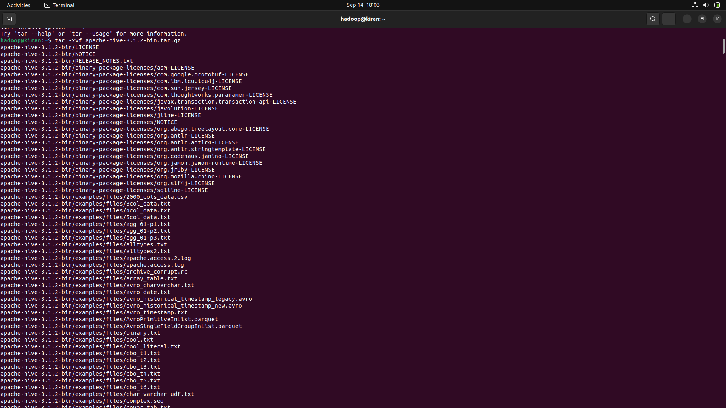

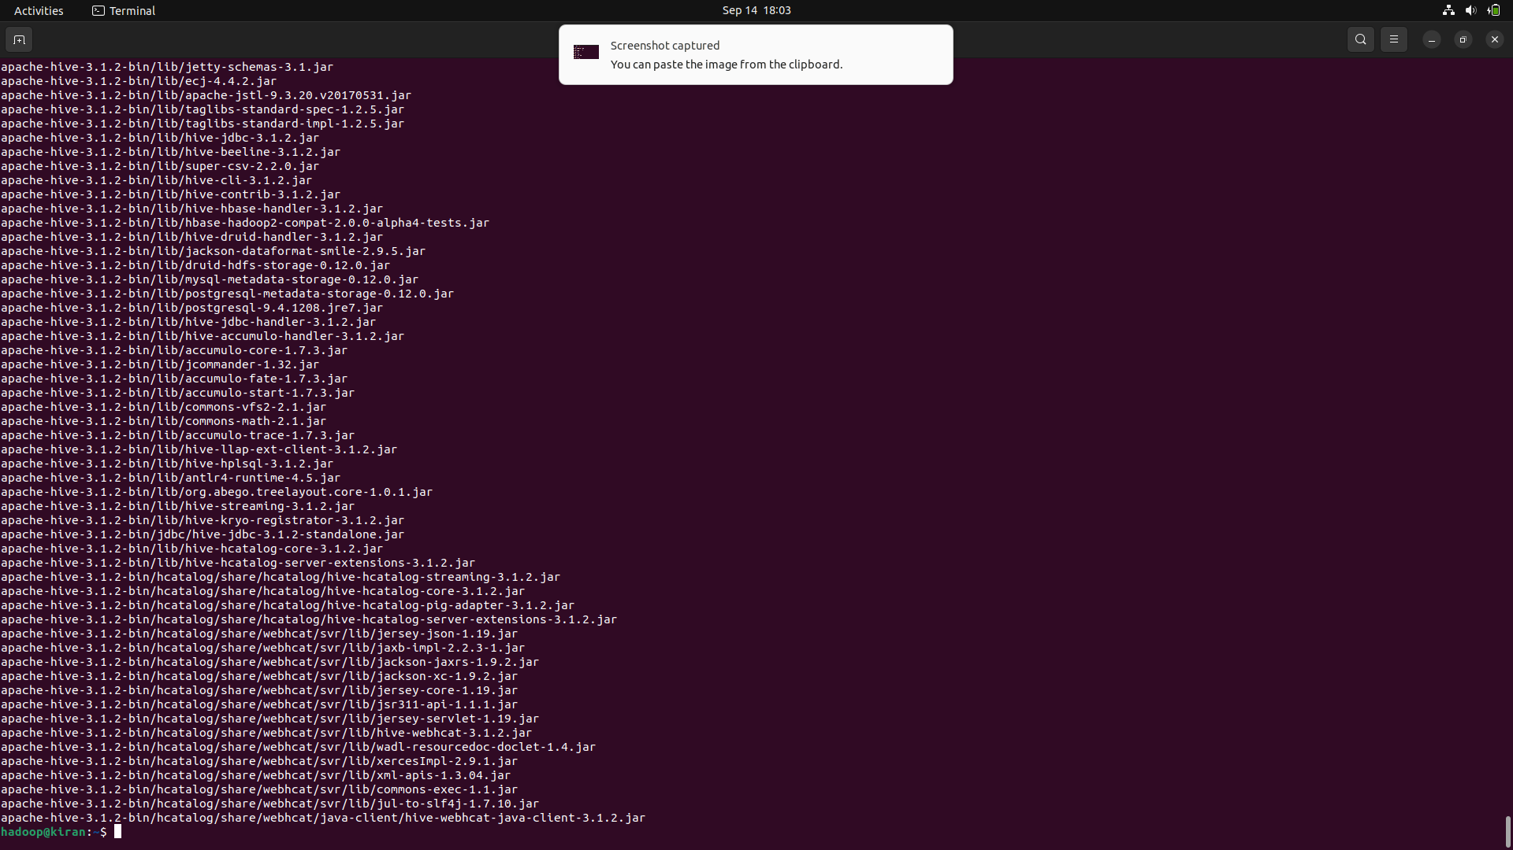

1. Update HIVE Configurations in .bashrc

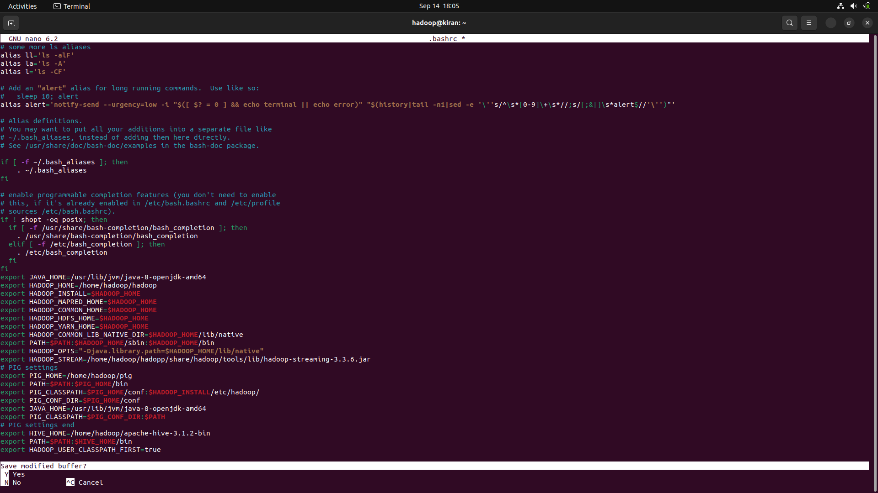

1. Change directory to apache-hive-3.1.2-bin/conf

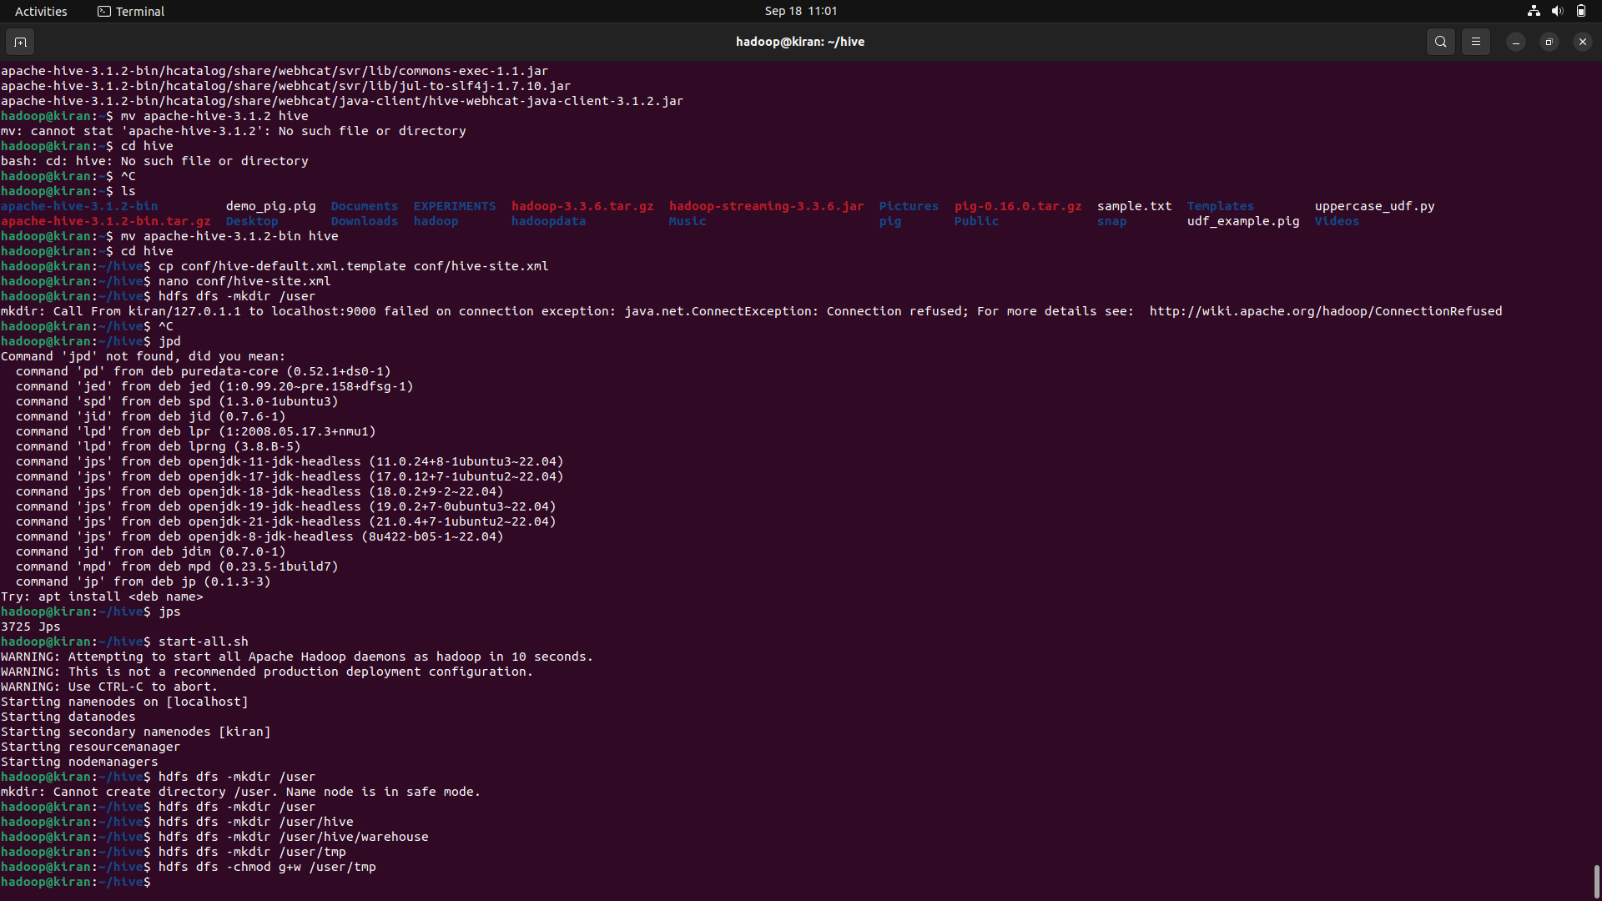

1. start-all.sh

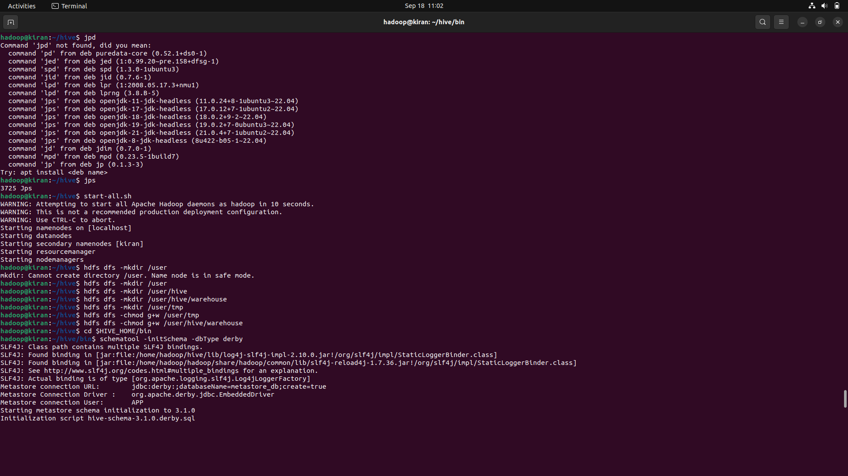

1. $HIVE_HOME/bin



1. $hive

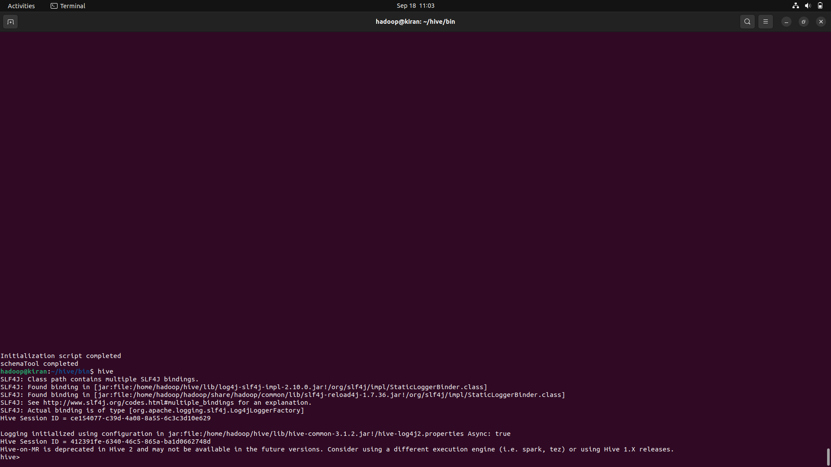

1. SQL commands

